Good Shepherd Congregation

The Kristin Alana Harder Memorial Scholarship

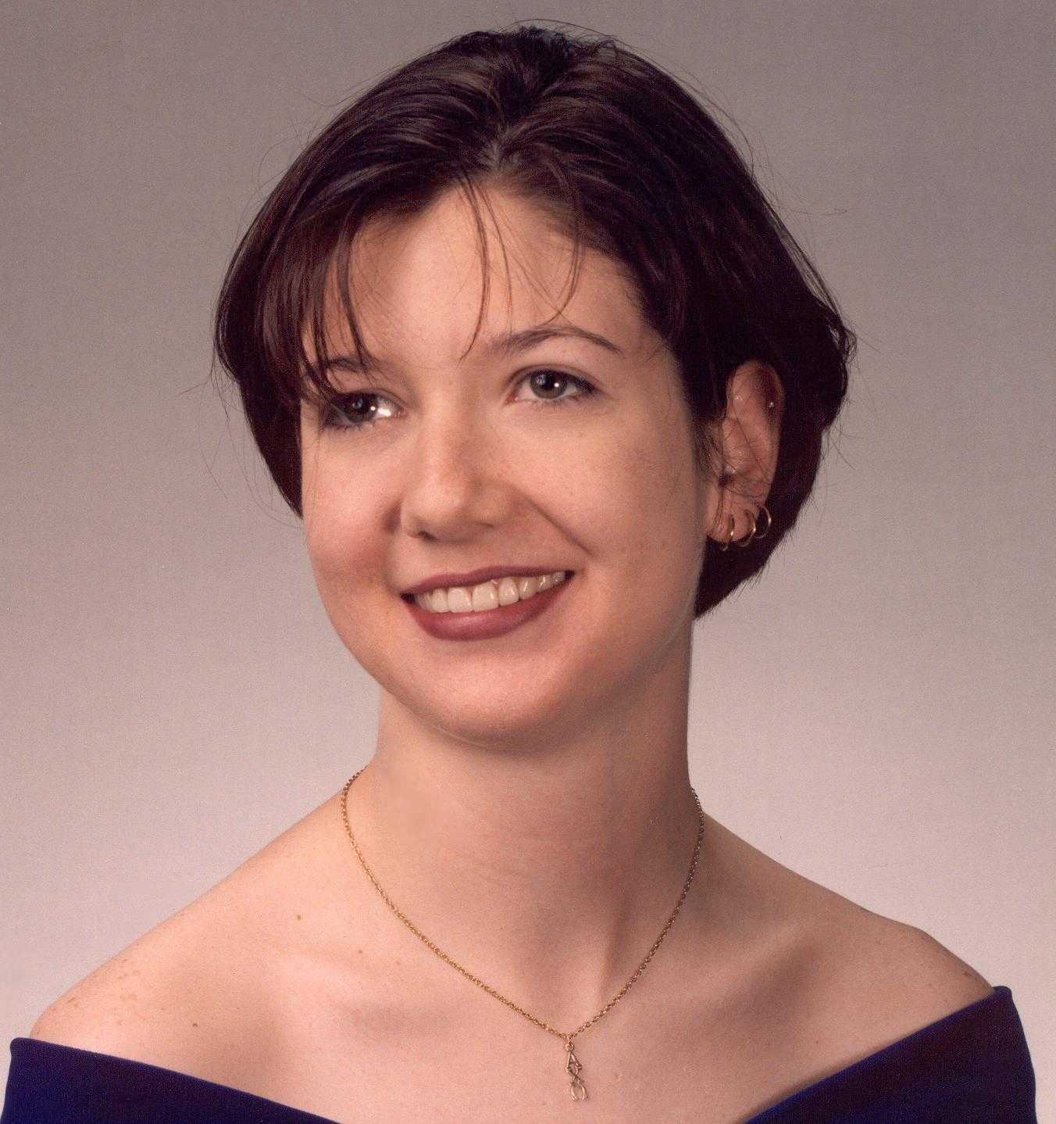
Kristin Alana Harder

Kristin Alana Harder was born March 5, 1977 in Independence, Missouri, to John and Mildred Harder. Two older brothers, Glen and Kevin, welcomed her into the family. Kristin was a very lovable and loving child who was quite creative in writing and art. Kristin had a wonderful sense of humor that drew many people to her. She was very brave and adventurous. Also, she had a keen appreciation for all that is beautiful in life.

Kristin was an active member of the Pleasant Heights Congregation and Santa Fe Stake. She was in Skylarks, Orioles, Zioneers, and Zion’s League. She attended many camps and retreats and took an exchange student from France to Sports Spectacular. She participated in numerous worship services, primarily through readings and prayers.

Kristin had a passion for music. She took piano lessons for ten years and became quite accomplished. In the fifth grade, Kristin began playing the violin; in her senior year, she was the concertmistress of the Truman High School orchestra. Also, Kristin loved to dance and enjoyed listening to a wide variety of music.

Kristin learned the difference between interest and commitment. When you are interested in something, you do it only when it is convenient; when you are committed, you accept no excuses, only results. After failing to make the Freshman Cheerleading squad, she took acrobatics lessons. In her sophomore year, she made the junior varsity cheerleading squad. In her junior year, she was a girls’ varsity cheerleader. In her senior year, she was co-captain of the boys’ varsity cheerleading squad.

Kristin achieved many honors in her high school academics. She was a member of the National Honor Society, the French National Honor Society, and was named to Who’s Who Among American High School Students. Other high school activities included participation in AFS, student council, French Club, and Spirit Club.

Some of Kristin’s greatest achievements came in college; she attended the University of Richmond, VA. The University of Richmond has highly selective admission requirements and a relatively small enrollment. When she arrived on campus, Kristin didn’t know anyone. When she graduated four years later, she had many wonderful friends. Kristin graduated from the E. Claiborne Robins School of Business with a Bachelor of Science in Business Administration; she had a major in marketing and a minor in French.

Kristin was quite involved in student life at the University of Richmond. She played violin in the university orchestra, was a disc jockey for the university radio station, was a member of Alpha Chi Omega social sorority, was a member of the Alpha Kappa Psi business fraternity and was involved in activities with Habitat for Humanity. During the spring semester of her junior year, Kristin studied at the University of Paris as part of the University of Richmond’s study abroad program.

After she graduated in May 1999, Kristin turned down several job offers on the east coast and came back to the Independence to be close to her family and friends. She was employed by Cyber Data Processing, an internet billing company. The president of the company was so impressed with Kristin during her interview that he created a job for her. Kristin really loved her work and the people with whom she worked; they loved her too. She brought a spirit of hard work, excitement, fun, and integrity to all she did.

Kristin was killed on March 11, 2000, as a result of massive internal injuries she suffered after being thrown from the back of a friend’s motorcycle. About four hundred fifty people attended Kristin’s memorial service at Pleasant Heights including people from many Christian denominations, Hindus, Muslims, and Jews; this is an example of how Kristin could bring people of many backgrounds together.

Kristin accomplished much and touched many lives for the better during her twenty-three years. She cannot be replaced. However, her family and friends who created the Kristin Alana Harder Memorial Scholarship at the Pleasant Heights Congregation, now the Good Shepherd Congregation, in hope that Kristin’s spirit will live on in the lives of those touched by this scholarship and that they in turn will accomplish much good in the lives of all those that they touch.

Good Shepherd Congregation

The Kristin Alana Harder Memorial Scholarship
Application Form 2021-22 Academic Year

Scholarship Considerations:
In loving memory of Kristin Alana Harder, John, Mildred, Glen, and Kevin Harder established the Kristin Alana Harder Memorial Scholarship at the Pleasant Heights Congregation, now the Good Shepherd Congregation, of the Community of Christ. The purpose of the scholarship is to provide financial assistance to students from Good Shepherd Congregation who are pursuing education beyond the high school level. Another purpose of the scholarship is to keep alive the memory of one of Good Shepherd congregation’s best scholars, thereby encouraging others to pursue excellence in their own personal development.
Applicants for The Kristin A. Harder Memorial Scholarship must meet the following criteria:
- Be a member of the Good Shepherd Congregation. Both attendance and participation will be considered.
- Be enrolled as a full-time student at an accredited university, college, or other post-secondary institution.
- Maintain a 2.5 grade point average on a 4-point scale in high school or college.
- Provide a written personal testimony of how God has worked in his/her life and share the testimony with the congregation.
- Not be related to John and Mildred Harder.
- Be interviewed by the Scholarship Committee.

When multiple candidates are being considered, preference shall be given to an individual attending a college, university, or post-secondary vocational school other than Graceland University. Further preference will be given to individuals that can document on the application form the following attributes:
- Plays a musical instrument and/or involved in a musical group such as band, orchestra, piano, vocal.
- Proficient in a foreign language, not necessarily a major field of study.
- Has achieved a 3.0 or greater grade point on a 4-point scale in high school or college.
Graduating High School Seniors must also meet the following criteria:
- Demonstrate 15 hours of service within a one-year time frame with at least 7 hours of service in the Good Shepherd congregation using the Service Record.
- Demonstrate attendance at Good Shepherd’s Sunday School, Worship Service or Wednesday Prayer Meeting at least 15 weeks within a one-year time frame using the Attendance Record.
Current college students must also meet the following criteria.
- Demonstrate 5 hours of service to the Good Shepherd Congregation, a local Community of Christ Congregation, the World Church, Graceland University, or a community organization demonstrating values aligned with those of Community of Christ within a one-year time frame using the Service Record.
Scholarships up to $1,000 are granted based on the available funds in any given year and are not self-renewing. A new application must be completed on an annual basis for renewal consideration.
Scholarship applications must be neatly prepared and submitted in a timely manner. In order to be eligible for a scholarship, applications must be received by Saturday, June 12, 2021. The term “within a one-year period” for determining eligibility for a scholarship is June 1, 2020 through May 31, 2021.
The attached forms are to be used to document and track your required activities. They must be neatly prepared, completed in detail, and submitted in conjunction with your completed Good Shepherd Scholarship Application Form.
Service Record: Please list each congregational and/or community activity, the date and the hours of service. Have an adult representative sign the sheet to verify your participation.
Attendance Record: Please list each week you attend a Good Shepherd Sunday School Class, Worship Service or Prayer Meeting. Have an adult representative sign the sheet to verity your attendance.
Personal Testimony: Please submit the title page along with your personal testimony.

Name:
Address:
City: |  |  | State: | Zip:
Phone: | eMail:
Year You Became a Member or Active Participant in Good Shepherd Congregation:
High School: |  | Graduation Date (mm/yyyy): |  | GPA:

Name of College, University or Post-Secondary Institution:
□ Post-Secondary □ Undergraduate □ Graduate Studies □ Other:
College, University or Post-Secondary Registrar’s Address:
Street:
City: | State: | Zip:
Phone: | Yearly Tuition:
Major Area of Study and Degree, if applicable: | Yearly Room and Board:
 | Books and Other Expenses:
Current GPA: | Total Yearly Cost:
Are you Receiving Other Financial Support? □ No □ Yes

List below your understanding of stewardship and ways in which you have exercised personal financial responsibility. Include examples of how you budget, save and contribute financially to the congregation and other organizations. If needed, use back of this page.
__________________________________________________________________________________________________________________________________________________________________________________________________________________________________________________________________________________________________________________________________________________________________________________________________________________________________________________________________________________________________________________________________________________________________________________________________________________________________________________________________________________________________________________________________________________________________________________________________________________________________________________________________________________________________________________________________________________________________

Signature: | Date:
The application form must be completed and returned to the Scholarship Review Committee, c/o Pam Ashley, 5217 Union St., Kansas City, Mo 64133, or email pamashley@billashley.com by June 12, 2021.
Service Record for All Applicants
June 1, 2020 thru May 31, 2021
List below ways in which you have actively participated in the Good Shepherd Community of Christ Congregation. Congregational service should include participation in worship services/prayer meetings, help with congregational activities, and help with clean-up after activities or on workdays.
*Requirement: 15 hours of service with a min. of 7 hours with Good Shepherd
Congregational Service Activity | Date |  | Hours | Congregation Rep. Signature
Additional Service Record for College Student Applicants
June 1, 2020 thru May 31, 2021
List ways in which you have also served in Community of Christ outside of Good Shepherd, Graceland University, in community organizations demonstrating values aligned with those of Community of Christ.
*Requirement: 5 hours of service
Congregational Service Activity | Date | Hours | Congregation Rep. Signature
Submit this Record with the Good Shepherd Harder Scholarship Application Form

Attendance Record for High School Seniors
June 1, 2020 thru May 31, 2021
Document the dates you have attended Good Shepherd Congregation Sunday classes, worship services or prayer meetings. Check the appropriate column for attendance.
*Requirement: 15 contacts
Date | Class | Worship  Service | Prayer  Meeting | Adult Signature
Submit this Record with the Good Shepherd Harder Scholarship Application Form

Testimony Cover Sheet

Applicants for the Good Shepherd College Scholarship Fund should use this cover sheet for submitting a personal testimony as one of their eligibility requirements.

The theme should focus on God’s workings, encouragement, or motivation in your life.

Entries must be neatly typed, double spaced, a minimum of two pages, and submitted on one side of 8.5” x 11” white paper. Include a title or topic for your testimony that communicates your idea. Attach an original copy of your testimony with this cover sheet and submit with your completed Good Shepherd Scholarship Application.

If selected for a scholarship, the congregation will work with you to schedule a time for you to share your testimony with the congregation. This could be done at a Worship Service, Prayer Service, Good Shepherd Retreat, etc.

Theme: How has God worked in Your Life?
Title:

Written By:

Signature: | Date:

Attach this Cover Sheet with an original copy of your typed testimony and
submit with the Good Shepherd Harder Scholarship Application Form.

